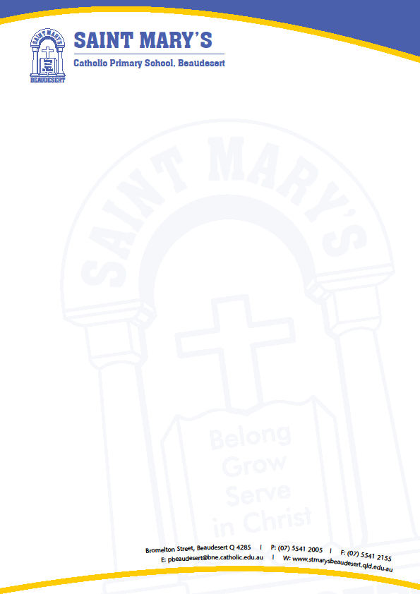

Mobile Phone/Smart Watch Policy

St Mary’s Catholic Primary School is implementing a Mobile Phone/Smart Watch Policy to ensure responsible use of mobile phones and Smart watches by students. The policy applies to students at the school while they are in class, on school grounds or involved in school activities on or off campus.

The WHY:
The increased ownership of mobile phones and SMART watches requires that we write a policy that clearly outlines expectations at St Mary’s. These expectations ensure that students are safe and are learning without the disruptions of technology.

Mobile Phone & Smart Watch Use:
- The use of mobile phones from the time of arrival at school until students leave school grounds, is strictly prohibited. During this time, mobile phones are to be handed in at Student Reception upon arrival and picked up at 2:50 pm.
- SMART watches are permitted at St Mary’s however whilst at school, students may only use them to tell the time, and notifications must be switched off. If a student accesses any other feature, in the first instance, the student will receive a warning. Any subsequent breach of this policy, the SMART watch will be confiscated and held in the school office. The parent/guardian of that child can pick up the SMART watch at their earliest convenience.
- The use of technology, to menace, harass or offend another person, is a criminal offence. While on school grounds, students who use their technology to harass another student, take unauthorised photos/video footage or post private information about another person, will have their technology confiscated and their right to have a mobile phone or SMART watch at school will be revoked. The school may involve the police should the mobile phone/ SMART watch be used inappropriately.
- If parents wish to communicate with their son(s) or daughter(s) during the school day, they are to call the School Office, and we will communicate the message to your child.

Student Name: Student Signature:

Parent Name: Parent Signature:

